Decision D.01-05-046 May 14, 2001

BEFORE THE PUBLIC UTILITIES COMMISSION OF THE STATE OF CALIFORNIA

ALAMEDA CORRIDOR TRANSPORTATION AUTHORITY (ACTA), for an order authorizing the construction or alteration of three railroad grade separations and thirty five highway grade separations, all located between Route 91 on ramp (CPUC Crossing No. 114-10.61-A) in the south and 25th Street (CPUC Crossing No. 114-0.70-A) in the north within the cities of Compton, Lynwood, South Gate, Huntington Park, Vernon, Los Angeles, and/or unincorporated portions of the County of Los Angeles, California, in the State of California. | Application 00-12-013  (Filed December 14, 2000)

OPINION

Summary
Alameda Corridor Transportation Authority (ACTA) requests authority to construct or alter three railroad grade separations (railroad over railroad) and thirty five highway grade separations (roadway over railroad). All these grade separations are located within the cities of Compton, Lynwood, South Gate, Huntington Park, Vernon, Los Angeles, and /or unincorporated portions of County of Los Angeles, in the State of California.

Discussion
ACTA was created in 1989 as a Joint Power Organization as a result of studies and planning activities that showed the need for a consolidated railroad link between the Ports of Los Angeles and Long Beach (Ports), and the regional and national railroad systems. Construction of a twenty mile, two track railroad link is planned upon the former Southern Pacific Transportation Company San Pedro Branch right-of-way that ACTA has acquired.
The fundamental purpose of the Alameda Corridor project is to provide improved goods movement without the adverse consequences of increased future freight rail traffic while at the same time sustaining economic growth. In addition to facilitating access to the Ports and accommodating the Ports’ growth, the planned corridor will reduce highway congestion, air pollution and noise which is most beneficial in residential areas. It will also reduce delays at existing at-grade railroad crossings and will provide enhanced safety. Train operations currently conducted over ninety miles of existing trackage will be consolidated into the new corridor which will be entirely grade separated and will greatly reduce present vehicular delays along the existing San Pedro Branch Line Corridor.
The entire Alameda Corridor Program has forty railroad-highway crossings along its three major sections:
1. The North End consists of several segments and ten public crossings. The Redondo Junction Grade Separation is one of these segments and extends from a point south of Olympic Boulevard along the west bank of the Los Angeles River, then continues southeasterly to the intersection of The Burlington Northern Santa Fe Railway Company (BNSF) right-of-way, east of Soto Street. PUC authority for construction of the Redondo Junction Grade Separation was requested in application (A.) 98-04-047, filed April 23, 1998. Another segment consists of the connection of the railroad tracks from the Ports to the BNSF San Bernardino Subdivision and to the Union Pacific Railroad Company (UP) tracks.
By Decision (D.) 98-10-015, dated October 8, 1998, the Commission granted authority to construct the railroad-railroad grade separation for the tracks of the Southern California Regional Rail Authority (SCRRA) to pass over the tracks of ACTA, the Union Pacific Railroad Company (UP) and BNSF.
Another North End segment involves construction of the Santa Fe Avenue Viaduct, a railroad bridge over Washington Boulevard to carry the ACTA main tracks, and a railroad bridge over Washington Boulevard that will carry two BNSF tracks connecting the BNSF San Bernardino Subdivision with the ACTA main tracks. PUC authority for construction was requested in application A.99-01-027, filed January 22, 1999.
By Decision D.99-07-042, dated July 22, 1999, the Commission granted authority to construct the Santa Fe Avenue Viaduct, and the railroad bridge over Washington Boulevard to carry the ACTA main tracks and two BNSF tracks.
Application A.00-03-049 was filed on March 24, 2000 for another North End project that will connect the ACTA main tracks to the Union Pacific (UP) tracks located on the east side of the Los Angeles River. The CPUC decision is pending.
Another North End segment involves the alteration of the existing Downey Road bridge (CPUC No. 2-144.5-B) to carry five BNSF tracks in place of the existing four tracks. The Commission granted the authority to construct by Decision (D) 00-06-072, dated June 22, 2000.
Also among the North End projects are the realignment of the east to west connecting track between the BNSF San Bernardino Subdivision tracks and the ACTA San Pedro Branch track across 26th Street (CPUC No. 2-144.72-C), and the realignment of the BNSF spur across 26th Street (CPUC No. 2-144.38-C).
2. The Mid-Corridor along Alameda Street between Santa Fe Avenue in Los Angeles and State Highway 91 in Compton will be a ten-mile, thirty-three feet deep, fifty-foot wide, depressed double-track railroad with twenty-nine road crossings and three railroad crossings above and across the depressed railroad. Included in this Mid-Corridor will be a 5.6 mile, at-grade UP by-pass track parallel to the depressed railroad along the East Side of the ACTA right-of-way. This at-grade connection has 17 grade crossings, two grade separations, and one separated railroad crossing, between the existing tracks at the State Highway 91 overpass and the track’s connection to the UP Santa Ana Branch, north of Firestone Boulevard. The Mid-Corridor extends from Los Angeles through the Cities of Los Angeles, Vernon, Huntington Park, South Gate, Lynwood, Compton, and the unincorporated County of Los Angeles. PUC authority for construction of this by-pass track was sought in application A.98-11-010, filed November 2, 1998.
By D.99-04-019, dated April 1, 1999, the Commission granted authority to relocate 17 single-track highway grade crossings; two single-track grade-separated highway crossings, and one grade-separated railroad crossing between Firestone Boulevard grade crossing and Auto Drive South, inclusive, in the County of Los Angeles, Cities of South Gate, Lynwood, and Compton.
3. The South End Corridor trackage extends at-grade along Alameda Street through unincorporated portions of the County of Los Angeles and the cities of Carson and Los Angeles to the Ports. These tracks serve Dolores Yard, the Intermodal Container Facility and various industries en route. Construction is underway to grade separate existing at-grade crossings that are the subject of applications filed and approved by the CPUC.
ACTA has filed the instant application A.99-02-013 for the construction of a two track grade separation above the reconstructed intersection of Henry Ford Avenue with on and off ramps of State Route 47 Freeway along with related grade crossing construction and relocation in the intermediate area in the City of Los Angeles.
County of Los Angeles has filed application 99-01-022 for the construction of a four track grade separation above Alameda Street in the County of Los Angeles in the Rancho Dominguez area.
Decisions for other South End projects have been issued as follows:
Del Amo Blvd. Grade Separation A97-07-006, D. 98-01-039
Sepulveda Blvd. Grade Separation A97-04-048, D. 98-01-038
Carson Street Grade Separation A86-12-09, D.87-09-058
Application (A.) 00-12-013 (instant application)
This project involves the construction of the three railroad grade separations (railroad over railroad) and thirty-five highway grade separations (roadway over railroad), all within the limits of the Mid Corridor Trench. Due to extreme complexity and length of this project, a full description of construction geometrics are described by plans and text attached to the application and are summarized by Exhibits listed below:
Lists of Exhibits to application
Exhibit A: Map of the Alameda Corridor Project and Vicinity
Exhibit B: Summary of Previous and Pending CPUC Filings
Exhibit C: CPUC Scoping Memo
Exhibit D: Details for Proposed Railroad Grade Separations
Exhibit E: Details for Proposed Highway Grade Separations
Exhibit F: Trench Typical Section No. 1
Exhibit G: Trench Typical Section No. 2
Exhibit H: Trench Typical Section No. 3
Exhibit I: Trench Typical Section No. 4
Exhibit J: Plan and Profile of ACTA Mainline Track Corridor within Trench
(Drawing No. ‘s T-016 to T-078 from ACTA Systemwide Trackwork
100% design)
Exhibit K: Right of Way Exhibits
Exhibit L: Letter Acknowledging Compliance with the State Clearinghouse
Lists of Acronyms and Abbreviations to Application
ACTA: Alameda Corridor Transportation Authority
BNSF: Burlington Northern Santa Fe Railway
Corridor: Alameda Corridor
CPUC: Public Utilities Commission, State of California
ICTF: Intermodal Container Transfer Facility (UPRR)
MTA: Metropolitan Transportation Authority, Los Angeles County
PU Code: Public Utilities Code, State of California
Ports: Port of Los Angeles and Long Beach
SPT: Southern Pacific Transportation Company (now UPRR)
UPRR: Union Pacific Railroad
USDOT: Department of Transportation, US Government
ACTA is the lead agency for this project under the California Environmental Quality Act of 1970 (CEQA), as amended, Public Resources (PR) Code Sections 21000, et seq. On June 27, 1997, the State of California Clearinghouse advised ACTA, that it had complied with State Clearinghouse review requirements for “draft environmental documents, pursuant to the California Environmental Quality Act (CEQA).” The United States Department of Transportation issued a Record of Decision approving Alameda Corridor Project. ACTA had previously prepared an Environmental Impact Report (EIR) on January 1993, and an Environmental Impact Statement (EIS) in February 1996.
The Commission is a responsible agency for this project under CEQA and has reviewed and considered ACTA’s environmental documentation. The site of the proposed project has been inspected by the Commission's Rail Safety and Carrier Division – Rail Crossings Engineering Section staff. Staff examined the need for and the safety of the proposed grade separation and related railroad construction, and recommends that the application be approved.
The application was found to be in compliance with the Commission's filing requirements, including Rules 38 to 41 of the Rules of Practice and Procedure. A site map of the grade separation is as shown on plans attached to the application and appendix A.
In Resolution ALJ 176-3053, dated December 21, 2000 and published on the Commission Daily Calendar on December 22, 2000, the Commission preliminarily categorized this application as ratesetting, and preliminarily determined that hearings werenot necessary. Since no hearings were held, this preliminary determination remains accurate. The Commission’s Rail Safety and Carriers Division recommends that this application be granted. Given these developments, public hearing is not necessary, and it is not necessary to disturb the preliminary determinations made in Resolution ALJ 176-3053.
This is an uncontested matter in which the decision grants the relief requested. Accordingly, pursuant to Public Utilities Code Section 311 (g) (2), the otherwise applicable 30-day period for public review and comment is being waived.

Findings of Fact
- Notice of the application was published in the Commission Daily Calendar on December 18, 2000. There are no unresolved matters or protests; a public hearing is not necessary.
- ACTA requests authority to construct or modify three railroad grade separations (railroad over railroad) and thirty-five highway separations (roadway over railroad). All these crossings are located within the cities of Compton, Lynwood, South Gate, Huntington Park, Vernon, Los Angeles and/or unincorporated portions of Los Angeles County, as more fully described by text and plans attached to the application as indicated by sample typical section in Appendix A of this order.
- The Alameda Corridor and related rail projects are required to provide improved goods movement, to accommodate the Ports of Long Beach and Los Angeles growth, reduce highway congestion, reduce air pollution and noise, which will benefit adjacent residential and industrial areas.
- Public convenience, necessity and safety require the construction of three railroad grade separations and thirty five highway grade separations, all located between the Route 91 on ramp in the south and the 25th Street in connection with
- The Alameda Corridor project, as set forth in Appendix A, and as more fully described by the plans and text in the application.
- ACTA is the lead agency for this project under the California Environmental Quality Act of 1970 (CEQA), as amended.
- The Commission is a responsible agency for this project and has reviewed and considered the lead agency's EIR, EIS, and U.S. Department of Transportation Record of Decision.

Conclusion of Law
The application should be granted as set forth in the following order.

ORDER

IT IS ORDERED that:
- Alameda Corridor Transportation Authority (ACTA) is authorized to construct three railroad over railroad grade separations and thirty five highway over railroad grade separations, all located between the Route 91 on ramp (Crossing Number 114-10.61-A) in the south and 25th Street (Crossing Number 114-0.70-A), in Los Angeles County, as set forth in Appendix A, and as more fully described and indicated by text and plans attached to the application.
- Construction and maintenance of the crossings shall be in accordance with the provisions of General Order (GO) 72-B.
- Clearances shall be in accordance with GO 26-D. Walkways shall conform to GO 118. Walkways adjacent to any trackage subject to rail operations shall be maintained free of obstructions and shall be promptly restored to their original condition in the event of damage during construction.
- All work on the Metro Green Line Light Rail System on State Route (SR) 105, if required, shall be in accordance with G0 143-B.
- Construction and maintenance costs shall be borne in accordance with an agreement entered into between parties. A copy of the agreement shall be filed by ACTA with the Commission's Rail Safety and Carriers Division prior to commencing construction.
- Within 30 days after completion of the work under this order, ACTA shall notify the Commission in writing that the authorized work was completed
- This authorization shall expire if not exercised within three years unless time is extended or if the above conditions are not complied with. Authorization may be revoked or modified if public convenience, necessity, or safety so require.
- The application is granted as set forth above.
- Application 00-12-013 is closed.
This order is effective 30 days from today.
Dated May 14, 2001, at San Francisco, California

LORETTA M. LYNCH
President
HENRY M. DUQUE
RICHARD A. BILAS
CARL W. WOOD
GEOFFREY F. BROWN
Commissioners

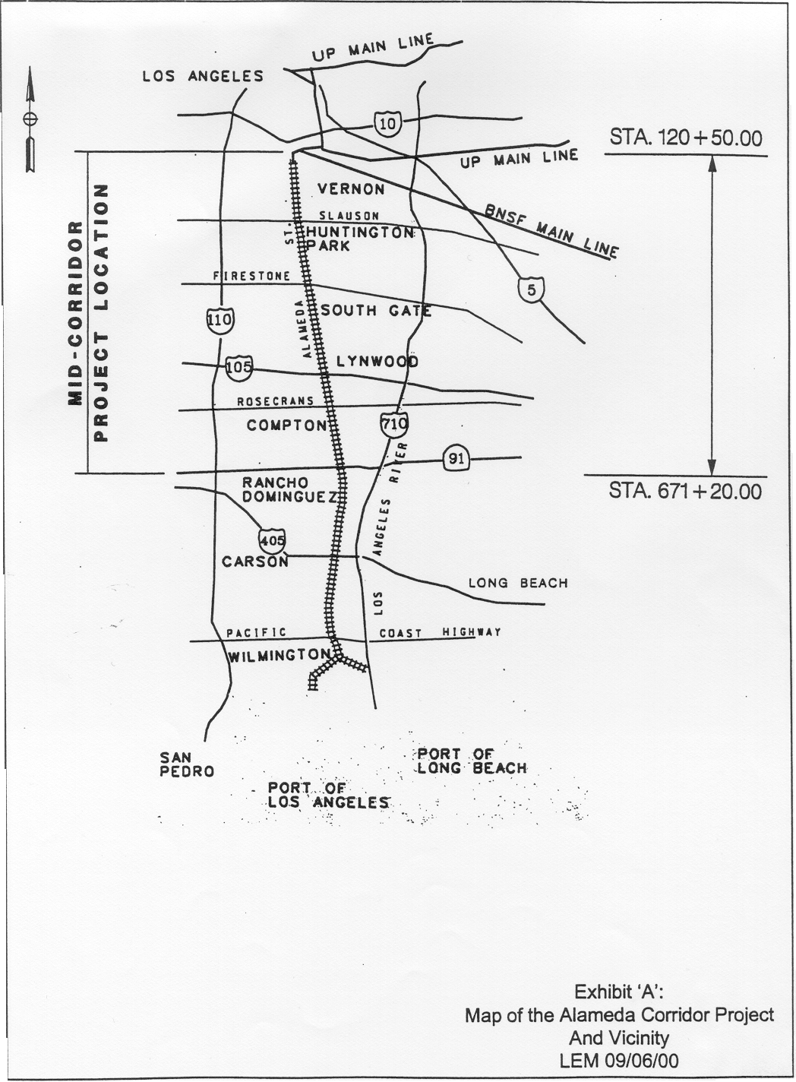
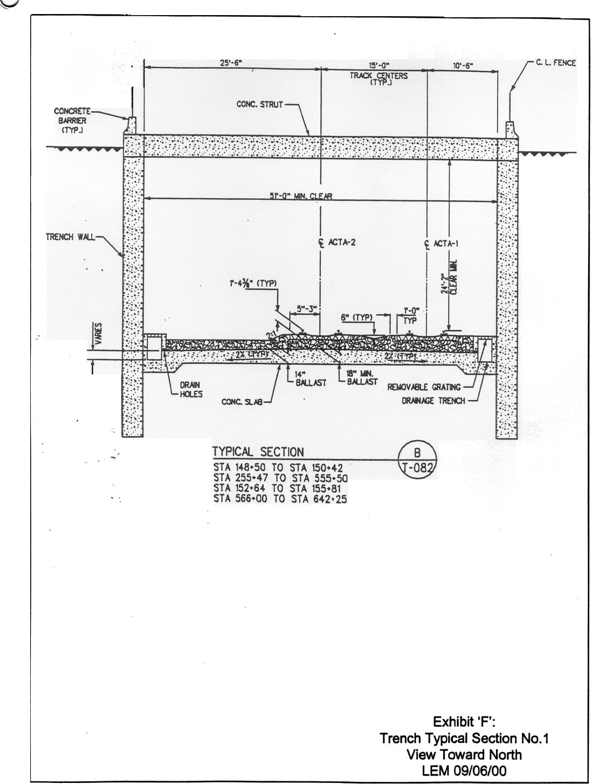
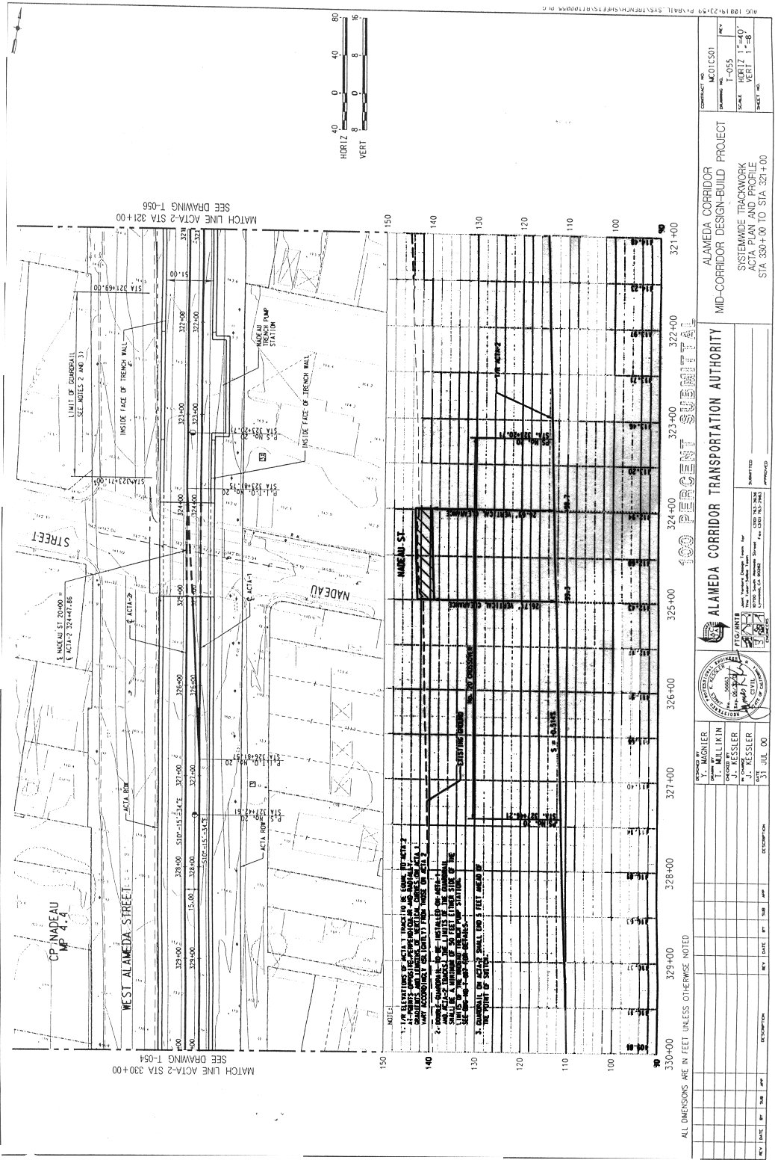
Full details for the three railroad grade separations and thirty five highway grade separations (roadway over railroad) are indicated on the plans attached to the application. A list of all these separations are listed below:
Railroad Grade Separations
CPUC  Crossing No. | Railroad Name | Jurisdiction | Vertical Clearance (ft)
114-6.64-AT | Metro Green Line at SR-105 | LAMTA | 52.23
114-2.60-AT | UPRR La Habra Subdivision at Randolph Street | UPRR | 24.30
114-2.50-AT | BNSF Harbor Subdivision at Slauson Ave. | BNSF | 24.27

Highway Grade Separations:
CPUC  Crossing No. | Highway Name | Jurisdiction | Vertical Clearance  (ft)
114-10.61-A | SR 91 Freeway EB Onramp | State of CA | 22.97
114-10.54-A | SR 91 Freeway | State of CA | 25.79
114-10.48-A | Artesia Boulevard | County of LA | 22.52
114-10.00-A | Greenleaf Boulevard | Compton | 23.06
114-9.50-A | Alondra Boulevard | Compton | 25.84
114-9.20-A | Myrrh/ Laurel Street | Compton | 25.06
114-9.00-A | Compton Boulevard | Compton | 26.34
114-8.80-A | Palmer Avenue | Compton | 25.64

Highway Grade Separations (Continued):
CPUC Crossing No. | Highway Name | Jurisdiction | Vertical Clearance (ft)
114-8.60-A | Elm Street | Compton | 26.53
114-8.46-A | Rosecrans Avenue | Compton | 56.04
114-7.90-A | 134th Street/Pine Avenue | LA County/  Compton | 25.31
114-7.60-A | El Segundo Blvd | LA County/  Compton | 24.77
114-7.30-A | 124th Street/Weber Avenue | LA County/  Compton | 24.46
114-6.90-A | Lynwood Road | Lynwood | 24.26
114-6.64-A | US 105 Interstate Freeway | State of Ca | 52.23
114-6.61-A | Imperial Highway | LA County/ Lynwood | 26.54
114-6.40-A | Santa Ana Blvd./Fernwood St. | LA County/  Lynwood | 26.04
114-6.00-A | Martin Luther King Blvd./  Century Blvd | Lynwood | 25.41
114-5.50-A | Tweedy Blvd | LA County/ South Gate | 27.28
114-5.00-A | 92nd Street/Southern Ave. | LA County/ South Gate | 25.65
114-4.70-A | Firestone Blvd. | LA County/ South Gate | 26.35
114-4.60-A | HON Furniture Driveway | Private | 25.26
114-4.40-A | Engle Driveway | Private | 24.63
114-4.00-A | Nadeau Street | LA County | 26.69
114-3.80-A | Metro Commercial Driveway | Private | 27.93
114-3.50-A | Florence Avenue | Huntington Park | 27.26
114-3.10-A | Zoe Avenue | Huntington Park | 24.44

Highway Grade Separations (Continued):
CPUC Crossing No. | Highway Name | Jurisdiction | Vertical Clearance (ft)
114-3.00-A | Gage Avenue | Huntington Park | 25.26
114-2.60-A | Randolph Street | Huntington Park | 24.30
114-2.50-A | Slauson Avenue | Huntington Park | 24.27
114-2.20-A | 55th Street | Vernon | 26.31
114-1.50-A | Vernon Avenue | Vernon | 28.29
114-1.20-A | 38th /41st Street | Vernon | 24.80
114-0.80-A | 27th Street | Vernon | 24.17
114-0.70-A | 25th Street | Vernon | 24.18

